Practical No. 10
Aim: Write a program to solve sum of subset problem for a given set of distinct numbers.
Software Requirements: Python IDE, PyCharm, Visual Studio Code, Jupyter Notebook
Theory: The Sum of Subset problem is a combinatorial problem where we aim to find subsets of a given set whose sum equals a specified target. It is commonly solved using a backtracking approach, where we explore all possible subsets and track whether their sum matches the desired value.
The backtracking algorithm eliminates unnecessary computations by abandoning paths where the sum already exceeds the target. This makes it more efficient than brute-force methods.
Algorithm Steps:
- Start with an empty subset and initialize the sum as zero.
- Recursively include or exclude elements while keeping track of the sum.
- If the sum matches the target, print the subset.
- If the sum exceeds the target or all elements are considered, backtrack.
- Continue this process until all valid subsets are identified.
Algorithm Analysis:
- Time Complexity: O(2^n) in the worst case, since every element has two choices (include/exclude).
- Space Complexity: O(n), as recursion depth can go up to the number of elements in the set.
Program Code:
def sum_of_subsets(arr, target, subset=[], index=0, current_sum=0):
if current_sum == target:
print(subset)
return
if index >= len(arr) or current_sum > target:
return
# Include the current element and recurse
sum_of_subsets(arr, target, subset + [arr[index]], index + 1, current_sum + arr[index])
# Exclude the current element and recurse
sum_of_subsets(arr, target, subset, index + 1, current_sum)
# Example usage
arr = [10, 7, 5, 18, 12, 20, 15]
target_sum = 35
print("Subsets with sum", target_sum, "are:")
sum_of_subsets(arr, target_sum)

Output:
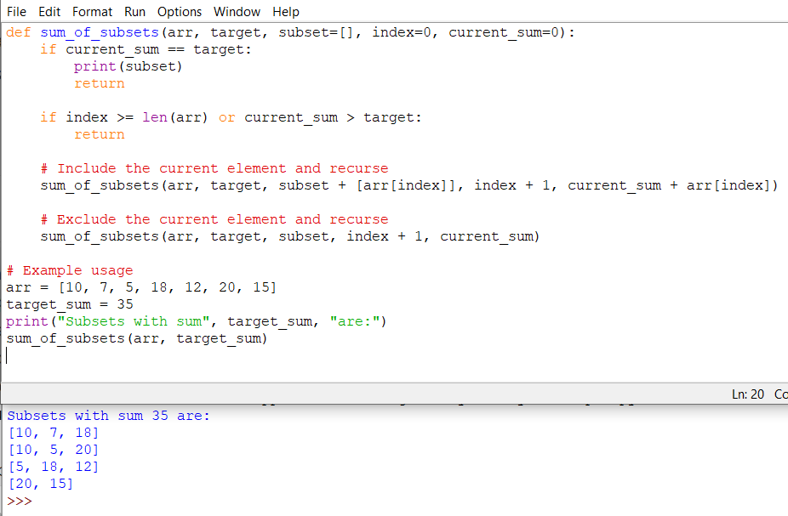

Conclusion: Hence, we have successfully executed the Python program to find all subsets whose sum equals a given target using a backtracking approach.

